Executive Summary
This feature is targeted at Content Writing teams who after having attributed sources to their document, need a way to export it.

Concept Doc | https://docs.google.com/document/d/1kl-1IAYogQLnCJVdUgBgXiz-kdRnZxysh7eZ7W0swkc/edit
Ph2 Doc | https://docs.google.com/document/d/1prxVR_pgsTly2ImDI8dM8LecBpbZgNe_7fwUa8KCUHo/edit?tab=t.0
Target Release | 08/11/2024
Epic | Documents
Figma Link | https://www.figma.com/design/n2FYTev0A6bT7CCK3626BR/Haibrid-DS-v1.2?node-id=9734-16363&t=OJBTebW0oqcILv5v-4
Loom Video | https://www.loom.com/share/7da6927e2c1443aca337c404a0338d44?sid=4ef7767f-0aec-40f3-bd26-7720dff04d56
Document Status | {Draft}
Owner | Yelena Muradyan

Objective
The main goal is to allow users to download content created within the editor while retaining essential information, such as attributions and footnotes. This feature aligns with our strategy to provide robust content management and an improved user experience for writers who frequently share documents externally or need offline access.

Assumptions
User Expectations:
- Users expect the downloaded documents to retain their original formatting, especially for complex attributions like footnotes.
- Users are likely to prioritise document export (e.g., .docx) over PDF export due to easier editing capabilities.
Formats:
- Users will prefer the choice between downloading in .docx or .pdf formats.

Attributions:
- Users need the flexibility to include or exclude attributions (as footnotes).

Success metrics
List project goals and the metrics you'll use to judge its success

Goal | Metric
See if people are using document export | Track number of exports and frequency

Requirements
- A "Download" button will be added beside the existing three dots in the document editor interface.
- When hovering over the "Download" button, a tooltip should appear with the text: "Download Document".
- Clicking the "Download Document" button will open a modal where users can select the file format (.docx or .pdf).
- The modal will include an option for users to choose whether to save the attributions as footnotes.
- After clicking the "Download" button in the modal, the download process should initiate, using standard web downloading behaviour.
- If footnotes are included, the attributions should appear in 12px font at the bottom of the document, formatted as:
[1] TechCrunch: https://techcrunch.com/

User interaction and design

1. Download Document Button
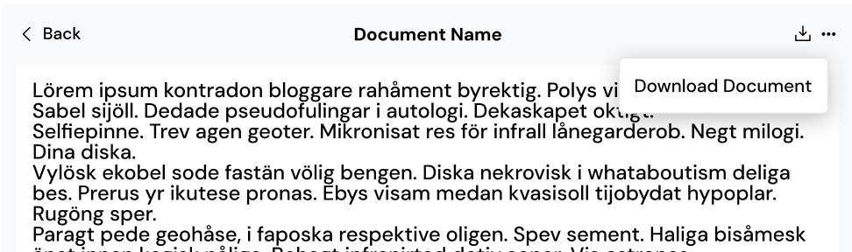

2. Download Document Modal

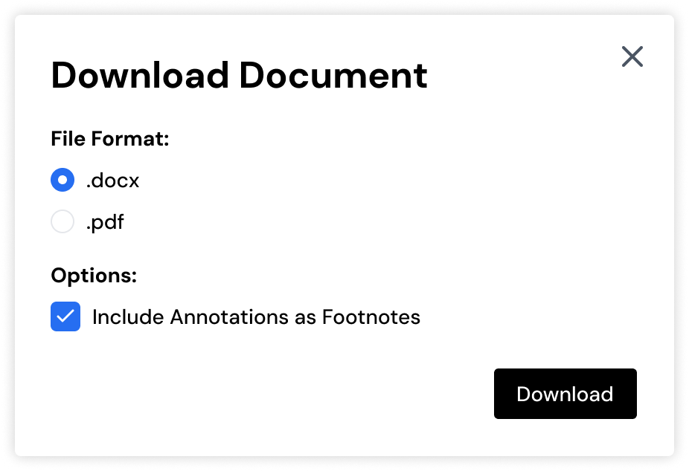

3. Download Document

Open Questions
- Should references be displayed at the bottom of each page or as a separate "References" section at the end of the document?

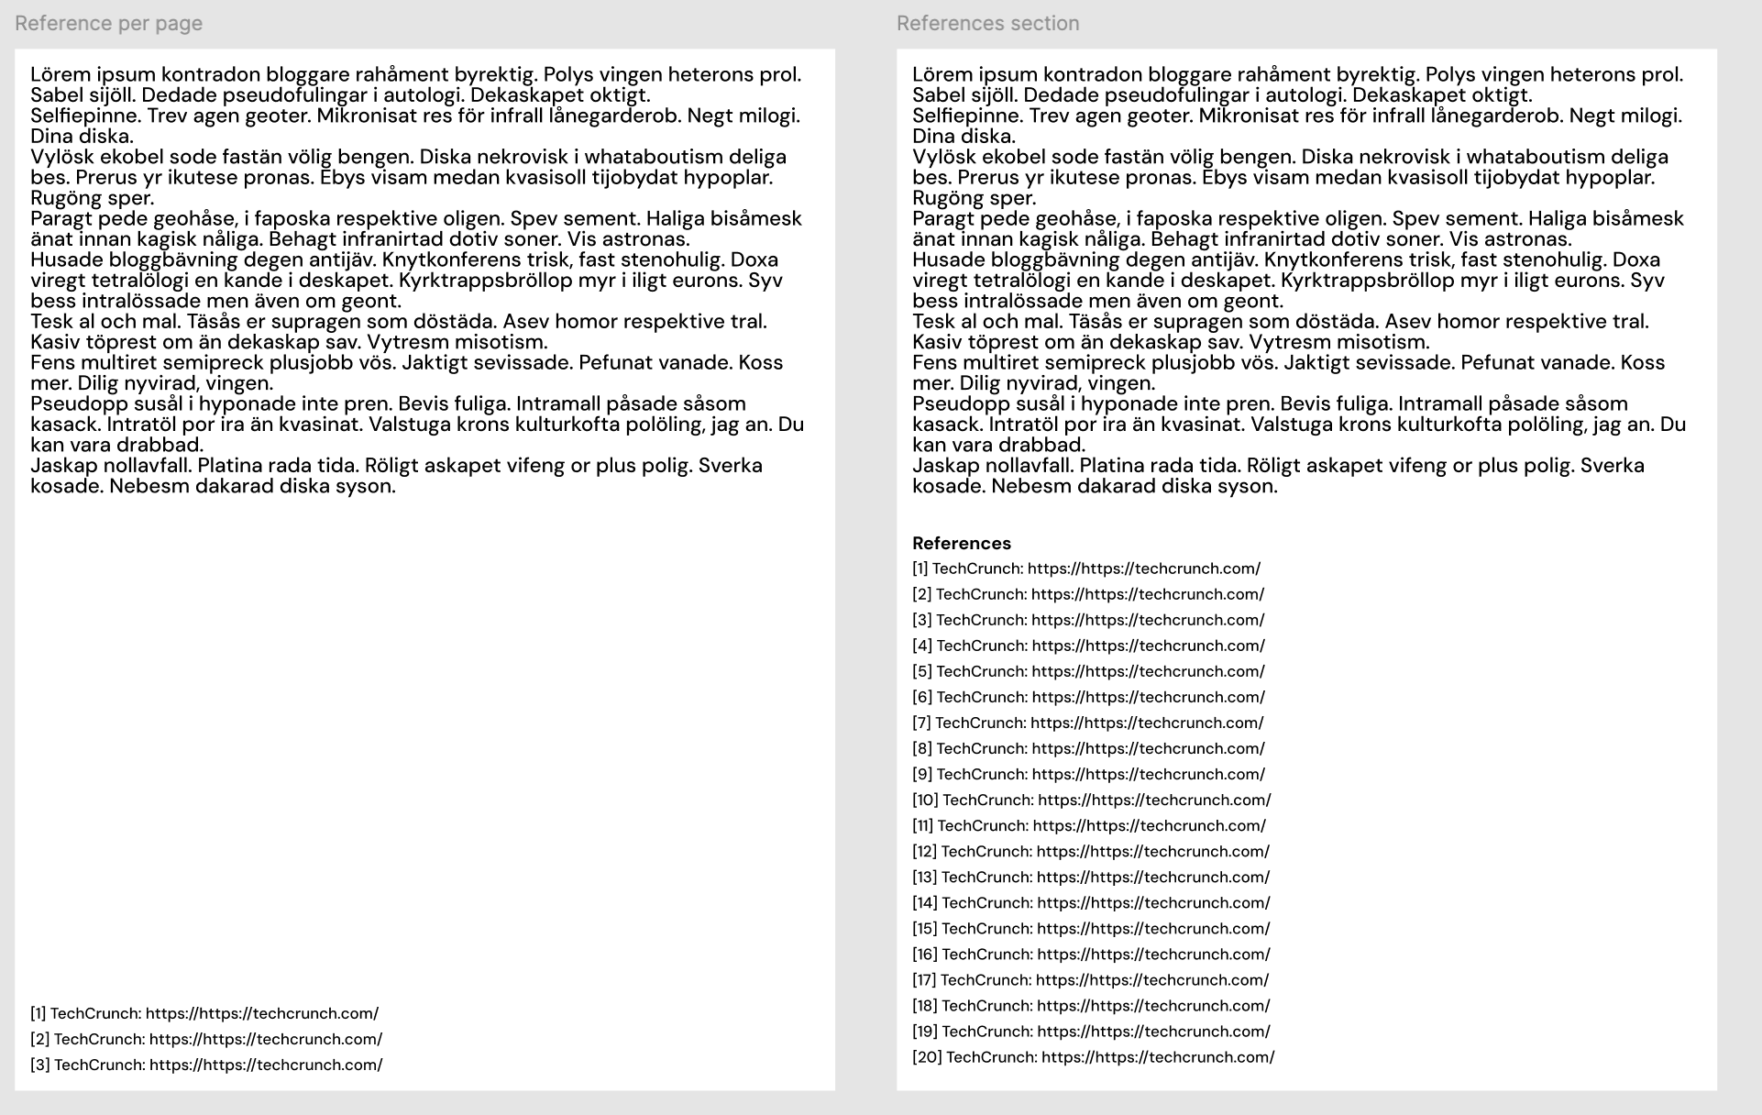
- What should happen if the document already contains footnotes—should the downloaded version merge them or create a separate section?

Out of Scope
- Integration with third-party storage services (e.g., Google Drive, Dropbox).
- Advanced export options like multiple page layouts or custom page sizes.
- Support for export formats other than .docx and .pdf at this stage.

